At Abellio we think of our people as our biggest strength and aim to set the highest standard for our Shared Service Centre (SSC). We expect our colleagues to:
- Deliver the best service to customers and internal stakeholders while demonstrating our values.
- Have awareness of statutory and regulatory requirements, as well as internal policies and procedures to ensure compliance.
- Understand your contribution to the wider SSC strategy and goals.
What’s your job? | Customer Experience Operations Manager
Who do you report to? | Head of Customer Experience
Where are you based? | Glasgow – Office Based
Which Team(s) are you in? | Customer Experience (CX)
Who do you manage? | Customer experience team leaders.
What core competences do you need? | Communication  Promotes an environment of open communication within and outside of the SSC, ensuring that sensitive information is protected. Inspires staff at all levels through his/her communication.  Teamwork  Motivates and empowers staff and fosters a collaborative approach across the SSC as a whole. Acts as a role model when handling disagreements.  Planning & Organising  Sets clearly defined objectives for the Department in line with the priorities of the SSC. Works toward SSC-wide efficiencies with a view to strengthening and harmonising planning systems and capacities at the Departmental level.  Managing & Leading  Serves as a role model to managers as well as to staff members in general. Demonstrates leadership, inspires others, and provides clear direction to achieve the SSC objectives and priorities. Motivates and empowers staff and recognises individual and team contributions to the SSC’s success.
What do you do? | Responsible for managing the performance of the CX team, motivating and developing staff to produce customer service excellence. Proactively manage delivery against a set of KPIs and organisational objectives taking prompt remedial action to ensure performance levels are met. Build strong stakeholder relationships and help the businesses we work with thrive by reducing stress in their day-to-day work life.
What are your key tasks? | - Analyse and interpret data to effectively manage performance within CX operation.  - Attend and participate in stakeholder account meetings periodically.  - Lead on daily and weekly calls with varying stakeholders to discuss performance and current issues with agreed actions and agenda.  - Manage CX related projects in line with the SSC Strategy and report on progress to the Programme Board.  - Deputise for Head of Customer Experience at senior leadership team level and liaise with department management team.  - Manage and coach the CX Team Leaders, supporting them to be effective in their roles, working smartly and efficiently to motivate and inspire their teams to achieve outstanding customer service.  - Coach CX Team Leaders to further strengthen and enhance their HR knowledge (including performance management, absence management, grievance issues, disciplinary) and delivery of HR related tasks and procedures.  - Create a culture of engagement, encouraging growth, personal development, and a great place to work.  - Manage performance and wellbeing through regular 121s and team meetings.  - Oversee CX team rostering, to ensure adequate resource available to meet customer demand.  - Create and effectively contribute to workforce planning to assess, analyse and forecast resource demand requirements to ensure SLAs are met within CX.  - Create, deliver, and sustain a robust process for all potential customer and/or internal fraudulent activity.  - Ensure continuous improvement to the quality of service we provide to our internal and external customers. Complying with both regulatory and advisory standards, ensuring best practice and industry learnings applied.  - Actively disseminate key company messages from the Senior Leadership Team, promoting them positively and appropriately.  - Proactively manage and aim to strengthen client relationships, through successful delivery of performance SLAs, continually reviewing areas of improvement and business processes to ensure exceptional service delivery.  - Ensure CX have a suite of process documents in line with business requirements which evolve and update via change control.  - Work closely with the SSC Head of Business Support on all engagement activities and safe working practices, helping to create a culture of fun and collaboration within CX and the wider SSC teams.  - Responsible for creating ways in which to celebrate successes, recognise great work and drive a high team engagement score.  - Manage risk within the department, escalating where necessary and ensuring mitigations are put in place.  - Work in conjunction with Training and Quality team to ensure CX standards are met and enhance ability to meet yearly quality score and departmental targets.  - Oversee CX recruitment and ensure process runs smoothly from application to onboarding.  - Manage colleague journey process for CX.
Who are your key stakeholders? | External – key contacts within the businesses we provide services to.  Internal – SSC Leadership Team, CX Management Team, HR, Project & Business Analysis, Business Support.
What must you have to do this job? | - Strong organisational skills  - Effective communication skills with the ability to communicate at a senior level.  - Ability to manage varying priorities at pace, meeting deadlines where appropriate.  - Drive for excellence and continuous improvement.  - Resilient approach and ability to work in an ever-changing environment.  - People skills and ability to influence stakeholders at varying levels.  - Awareness of CRM systems and ability to interpret business data.  - Ability to lead from the front.
What would it be good for you to have to do this job? | - Previous experience within fast paced contact centre environment, ideally rail industry.  - Quick learner with ability to work at pace.  - Previous experience leading large teams.
What do we expect from you? | Our people are out greatest strength so we would expect a supportive leadership style, embracing our values.

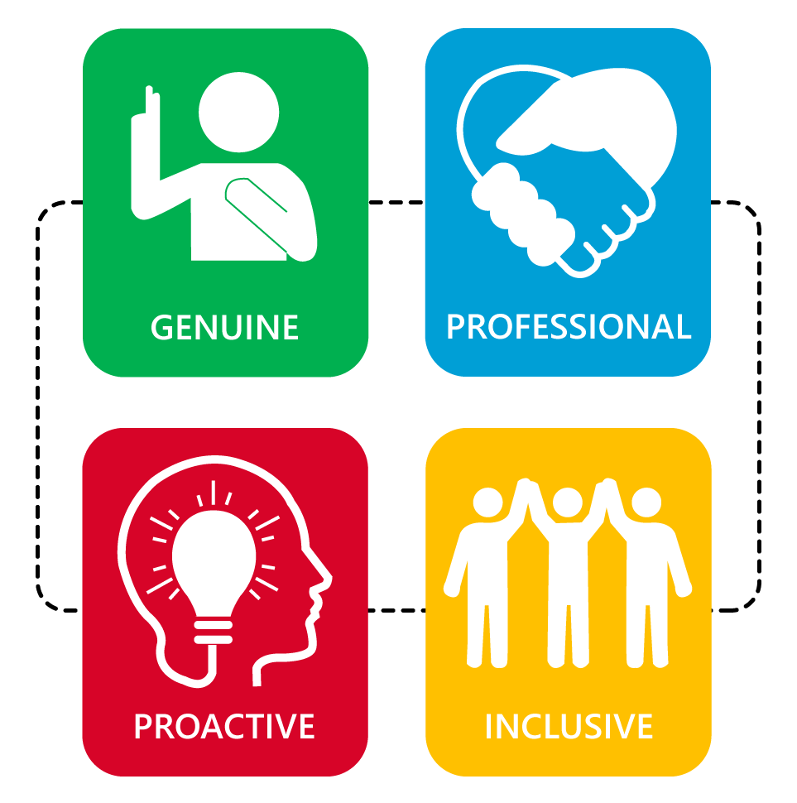
Abellio Values
