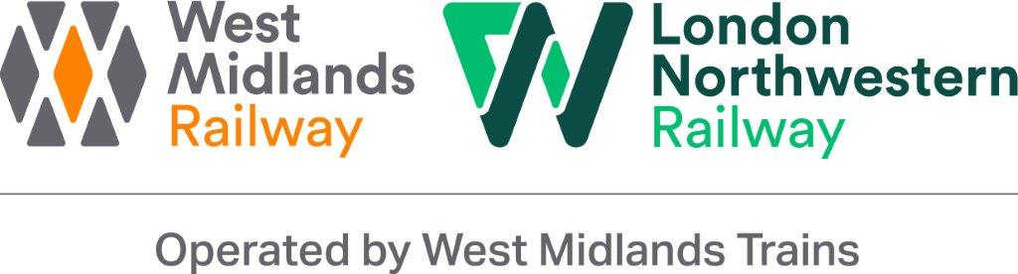

Duty Control Manager

JOB DESCRIPTION

Job Holder: Duty Control Manager

Reports to: Control Manager

Grade: Controller “A”

Safety Status: Key Safety

Date:

1. Job Purpose

- Responsible for the management, operation and performance of all West Midlands Trains services by ensuring the efficient and cost effective utilisation of the West Midlands Trains resources and that performance meets the required targets.

- Also to implement contingency plan as required.

2. Safety Details
A. This job requires Security Clearance (e.g. Running of Special Trains)
B. The job holder is required to hold a relevant Track Safety competence (e.g. PTS)
C. This is a Safety Critical Work Post
D. This is a Key Safety Post
E. Reference to this job is included in West Midlands Trains Safety Certification documents
F. This job Manages Employees (undertakes specific tasks indicated in the occupational & operational standards manuals)
G. This job Manages Locations (undertakes specific tasks as indicated in the occupational and operational standards manuals)

3. Dimensions

A. Financial:

There are no Financial dimensions to this post

B. Staff:

Fleet Managers
Maintenance Control Managers
Train Services Managers
Information Controllers
Passenger information & security centre Controllers
Level 1 Delay attribution controllers

C: Others:

Duty Route & Incident controllers at Rugby ROC

4. Principle Accountabilities

- Reports to the Control Operations Manager
- Authority to make real time alterations to West Midlands Trains train services based on available information, knowledge and experience, giving full consideration to West Midlands Trains passenger requirements
- Authority to book taxis, customer alternative transport and emergency expenditure to delegated authority limits
- Ensure compliance with all safety responsibilities as detailed in the appropriate Safety Responsibility Statement
- Achieve agreed performance targets
- Ensure compliance with Rule Book and Appendices
- Ensure compliance with safety standards
- Ensure delivery of the train diagram
- Dispensable for all safety of the line incidents
- Provide the focal point for West Midlands Trains on call arrangements
- Provide the focal point for the implementation of West Midlands Trains Emergency Plan
- Produce the West Midlands Trains daily control log, which will include all relevant safety and performance information
- Responsible for internal check procedures within the Control department
- Provide real time management of the Control department
- Examine West Midlands Trains unit/maintenance/service arrangements and their relevance and advise Control Operations Manager of any emerging trends
- Supervise Control Room team, providing guidance, support and coaching as required
- Any other duties commensurate with the grade and post and as required.

5. Context

A: Operating Environment:

The post is required to interface with internal and external parties including senior management, Maintenance depots, Train Crew Depots, traincrew, station colleagues, media, network rail NRES and other Train Operating Companies.

The post is based within Control in the Network Rail Signalling Centre at Saltley, Birmingham.

B: Framework and Boundaries:

This post has significant latitude to formulate and dissemination of service amendments, contingency plans information and to meet the PIDD ACOP.

C: Organisation:

See Appendix A.

6. Relationships

A: Subordinates:

Maintenance Control Managers
Duty Route & Incident Officers
Fleet Managers
Train Service Managers
Information Controllers
Passenger Information & Security controllers
Level 1 Delay Attribution Controllers

B: Superior(s):

This post reports to the Control Operations Manager.

C: Other Contacts:

(i) Within the Company:

Senior Management, On call Staff, depots, Duty Train Crew Managers traincrew, station colleagues.

(ii) Outside the Company:

The Media, NRES, Network Rail and other train operating companies.

7. Knowledge and Experience

- Effective communicator at all levels of the organisation
- Highly developed organisational skills and self starter
- Demonstrable prioritising skills
- Methodical
- Enquiring/analytical & questioning mind
- A minimum of two years Control experience within a Train Operating Company or Network Rail control office.
- A thorough knowledge of Rules and Regulations, standards and procedures relating to West Midlands Trains is essential.
- Understands Customer needs
- Understanding of West Midlands Trains operations, standards and procedures
- Thorough knowledge of West Midlands Trains routes and geography
- Experience of a customer service environment would be an advantage
- Good knowledge of traincrew terms and conditions of service
- Knowledge of software including Word, Excel, Tyrell IO, Trust, Genius, P2, CCIL log, Winpop Messenger and CCF.
- Flexible
- Ability to remain calm and work under pressure
- Attention to detail
- Able to prioritise own workload
- Able to handle large amounts of information
- Articulate and numerate
- Computer literate with good keyboard skills
- West Midlands Trains Induction programme attendance for new entrants
- Holder of A1 qualification or equivalent
- Holder of V1 qualification beneficial

8. Job Challenge(s):

- Ensure the train service is returned to normal as soon as possible following service disruption, keeping disruption to customers to a minimum
- Ensure customers are provided with the best alternative journey options when planned services are disrupted.
- Ensure all control staff are compliant with OPS 607 Controllers competence management system
- Ensure PIDD compliance
- Any other duties commensurate with the grade and post and as required.

9. Additional Information

None

10. Sign off

Job Holder:……………………………………………….. Date:………………..

Manager:………………………………………………….. Date:………………..

Nominated Deputies

If this is a KEY SAFETY POST (2 in Safety Details above is “ticked”) a Nominated Deputy must be identified. The job holder must ensure that the Nominated Deputy receives a copy of, and is briefed on, this Job Description.

Job title of
Nominated Deputy: ……………………………………………………………....

Name of
Nominated Deputy: ……………………………………………………………….

Signature of
Nominated Deputy: ……………………………………………………………….

Date: ………………………………………………………………………………….

As the Nominated Deputy for this post, I confirm that I have been briefed on the requirements of this job. If there are more Nominated Deputies they should sign further copies of this Job Description.

