Job Holder: Traincrew Support Manager

Reports to: Resource Strategy And Delivery Manager

Grade: PM2

Safety Status: Key Safety

Date version agreed: March 2018

A. This job requires Security Clearance (e.g. Running of Special Trains) | No
B. The job holder is required to hold a relevant Track Safety competence (e.g. PTS) | Yes
C. This is Safety Critical Work Post | No
D. This is a Key Safety Post | Yes
E. Reference to this job is included in West Midlands Trains’s Safety Certification documents | Yes
F. This job Manages Employees (undertakes specific tasks indicated in the occupational & operational standards manuals) | Yes
G. This job Manages Locations (undertakes specific tasks as indicated in the occupational and operational standards manuals) | Yes
1. Job Purpose

To lead, develop and manage the delivery and organisation of the operational training from Business Induction to Productivity, ensuring that all training targets are met within timescale and recovery plans are implemented where necessary.

Furthermore, this role will strategically develop the training plans of all Traincrew, providing guidance to the Roster Manager and Resource Manager, as well as the operational line management team for training resourcing issues including the review of outstanding legacy training and any signaling schemes which require training.

2. Safety Details
A. This job requires Security Clearance (e.g. Running of Special Trains) | NO
B. The job holder is required to hold a relevant Track Safety competence (e.g. PTS) | NO
C. This is a Safety Critical Work Post | NO
D. This is a Key Safety Post | YES
E. Reference to this job is included in London Midland’s Safety Certification documents | NO
F. This job Manages Employees (undertakes specific tasks indicated in the occupational & operational standards manuals) | NO
G. This job Manages Locations (undertakes specific tasks as indicated in the occupational and operational standards manuals) | NO

3. Dimensions
(Indicate in quantitative terms the key areas on which the job has an impact)
A. Financial:

Responsible for the costs associated with delays within Traincrew training and delivery ensuring the training is delivered as efficiently and safely as possible.

B. Staff:

No Direct Reports but direct liaison with other functions and grades to ensure training is identified and delivered within timescales.

C: Others:

Compliance with employment Law/Legislation
Compliance with any trade union agreements and terms and conditions
Compliance with Data Protection Act

4. Key Accountabilities

- Strategically and tactically lead the training and resourcing tracking process and system for all schemes and legacy training. This includes clear planning and delivery of associated courses in liaison, focusing on resource availability throughout the course and planning for contingency where necessary.
- Work within the parameters of all agreed company and local traincrew agreement.
- Actively liaise with internal stakeholders and external stakeholders to ensure consistent approach to delivery of training plans.
- Work with Area Driver and Conductor management team to deliver continued improvement and efficiency in training delivery and reviews.
- Monitor & Manage the tracking and scheduling system for both legacy and one of training.
- Identify all resourcing & Training opportunities (e.g. forward planning and traincrew detachments) to impact on the legacy training within the business.
- Develop, review and manage legacy training plans with the Area and Local Management teams.
- Produce, implement and manage re-signaling scheme briefings, one off training and one-off route learning plans within the operations team.
- Liaise with Manpower Planning Manager, Roster Manager and Resource Delivery Manager on a periodic basis to review the impact of training on service delivery.
- Liaise with ADM’s / APSM’s to achieve efficiencies in the depot with regard to training and potential training link structure.
- Complete periodic KPI reports on Training plans and progress.
- Support the Resource Strategy and Delivery Manager at external meetings with system suppliers including periodic reviews of the system and system development opportunities.
- Train and provide help and support to other staff/ departments on internal systems.
- Assisting the Resource Team during timetable change with the production, validation and implementation of new rosters.
- Management of the Taxi contract, validation of taxi invoices and administration of any traincrew taxi issues and complaints.
- Involvement and support in the production of ‘At Risk Services’ list, and daily conference calls as required.
- Work as Directed by Resource Strategy and Delivery Manager.

5. Context

A: Operating Environment:

Traincrew terms and conditions covered by a legacy of collective agreements across a number of trade unions.
Management of training tracking process working with collectively bargained agreements and direct liaison with the frontline management teams

B: Framework and Boundaries:

The nature of the collective agreements means that a detailed knowledge of terms and conditions and their implications is essential to the role. This is coupled with the need to build good working relationships and communication with line managers and union representatives in order to engender employee engagement.

C: Organisation:

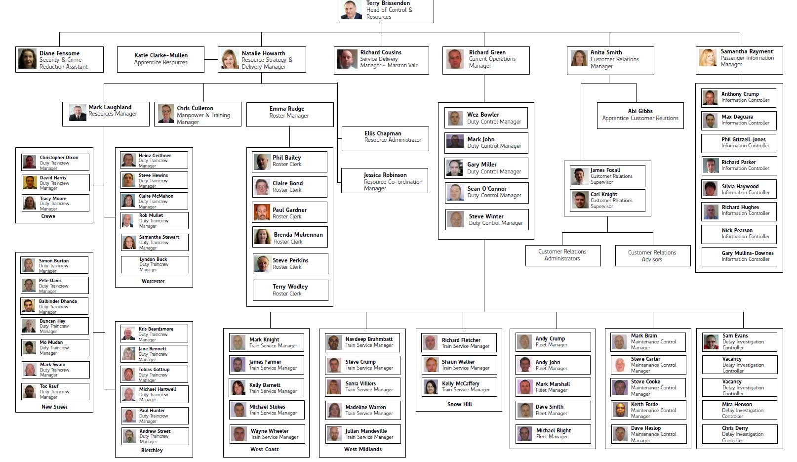

6. Relationships

A: Reporting lines

Direct Reports; None
Line Manager; Resource Strategy and Delivery Manager

B: Other Contacts:

Internal – Driver and Conductor Management, Planning, Resource managers, DTCM, performance, HR & Finance business partners, Safety, Fleet, Academy, Recruitment & IT.

Outside the Company:

ATOS Origin, Network Rail, Other IT or Systems providers and other TOC management.

7. Knowledge and Experience

Knowledge
- Good knowledge of London Midland operations and geography
- Knowledge of Driver and Conductor terms and conditions.
- Knowledge of safety and quality standards.
- Previous knowledge of People Management and tracking systems

Skills
- Highly credible leader with a proven track record of performance managing and motivating others to deliver results. Willing to challenge poor performance.
- Pro-active individual with an ability to engage with others quickly to establish relationships on all levels.
- Excellent communicator with strong negotiation and influencing skills.
- Able to understand and absorb substantial amounts of information quickly and accurately and drive appropriate action to deliver realistic solutions.
- Well developed written and verbal communications skills.
- Excellent people and team leadership skills.

Experience
- Experience of working in a highly unionised and/or operational environment. Thrives in complex and demanding situations. Can demonstrate a high level of personal resilience.
- Experience of problem solving and development of strategic training plans
- Experience of deploying strategic priorities whilst maintaining performance delivery.
- Experience of managing diverse teams through change, developing talent and coaching others.
- Experience of managing complex tasks with an attention to detail.

8. Sign off

Job Holder:……………………………………………….. Date:………………..

Manager:………………………………………………….. Date:………………..

Nominated Deputies

If this is a KEY SAFETY POST (2D is “checked”) a Nominated Deputy must be identified. The job holder must ensure that the Nominated Deputy receives a copy of, and is briefed on, this Job Description.

Job title of
Nominated Deputy: ……………………………………………………………....

Name of
Nominated Deputy: ……………………………………………………………….

Signature of
Nominated Deputy: ……………………………………………………………….

Date: ………………………………………………………………………………….

As the Nominated Deputy for this post, I confirm that I have been briefed on the requirements of this job. If there are more Nominated Deputies they should sign further copies of this Job Description.

Safety & Environmental Safety Responsibility Statement

It is the line manager’s responsibility to ensure that the post holder is fully briefed and responsibilities are clearly understood by the post holder.
This statement must be amended and accepted:
- Wherever responsibilities are changed;
- In response to an accident or incident;
- In response to external changes to Health and Safety and Environmental Legislation; and/or
- Following annual review.

General Responsibilities
Overarching Safety and Environmental Responsibilities are as follows:
- You must take reasonable care for your own health and safety and of persons who may be affected by your acts or omissions at work;
- You must co-operate on matters regarding safety and health;
- You must not interfere with anything provided in the interest of health and safety – for example override safety features of equipment;
- You must follow the training you have received when using any work items your employer has given you;
- Tell someone (your employer, supervisor or health and safety representative) if you think the work or inadequate precautions are putting anyone’s health and safety at serious risk;
- You must support the business in achieving its objectives laid out in its latest Environment & Energy Policy.

Further Safety and Responsibilities that apply to all West Midland Trains employees are set out below, in sections which correspond with the West Midland Trains Safety Management system.
You must take reasonable care for your own health and safety, and of persons who may be affected by your acts or omissions at work.
- Policy, Leadership and Resourcing
  - You must understand and comply with the Refusal to work on the grounds of health and safety policy.
  - You are responsible for attending the following safety and / or environmental related meetings:
E.g. Sustainability Action Group, SEMG
List meetings here
☐ None apply
  - You must comply with the West Midland Trains policy on the use of mobile phones when driving on company business.

- Employee training
  - You must attend the necessary safety and/or environment training courses within 3 months of appointment (or as soon as practicable thereafter).

- Planned Inspections
  - You must comply with the procedures which exist to remedy substandard acts and conditions found in the workplace.

- Accident and incident investigation
  - You must ensure that all personal accidents and near misses are reported to your supervisor or Control as detailed on the health and safety notice board.
  - You must ensure that all personal accidents are reported and investigated as detailed in the Accident/Incident Reporting and Investigation standard.

- Emergency planning and Security
  - When working at static locations you must ensure that you understand the local emergency plan at each location at which you are required to work. Local emergency plans are detailed on safety notice boards.
  - You must understand and comply with your obligations regarding security checks, suspect packages, bomb threats and explosions as detailed in the West Midland Trains Occupational Standards Manual.

  - You must understand and comply with your obligations regarding security checks, suspect packages, bomb threats and explosions as detailed in the West Midland Trains Occupational Standards Manual.

- Rules Competencies, Permits and Licences
  - You will receive an assessment of competence in the rules, regulations and instructions which apply to your post. The initial and subsequent assessments will be given by qualified trainers/assessors. Competence processes will lead to certification. You must ensure that you maintain your own competence in rules, regulations and instructions for the post that you hold.
  - You must be in possession of the necessary publications, as detailed by your manager or supervisor before you take up your post.
  - You may be required to drive motor vehicles owned, hired, or leased by West Midland Trains. You must not do so unless in possession of a valid license appropriate to the vehicle being driven. You must be insured to use that vehicle and fully comply with the Authority to Drive procedures, carrying the appropriate authority card.

- Communications
  - You must ensure that you attend regular briefings which cover safety and environmental issues.
  - You must attend any local job induction training session on your first day at a new location.

- Auditing and safety Check
  - You must ensure that substandard conditions found by you in West Midland Trains workplaces are reported to the appropriate line manager or Control without delay.
  - You must ensure that any practices undertaken that do not align to current policies or standards are reported to your Line Manager or Control without delay.

- Promotion of Environment & Safety Issues
  - You must ensure that you are aware of the location and are familiar with the contents of the safety and environment notice board.

- Health Controls
  - You must understand and comply with the alcohol and drugs policy as detailed in OCC-205 Alcohol and Drugs and other policy documents.
  - You must understand and comply with the standard for Control Of Substances Hazardous to Health (COSHH).
  - You must understand and comply with the standard for Control of Asbestos.
  - You must understand and comply with company standards for management of cases of occupational ill health.
  - You must understand and comply with the standard for Staff Care and Support System (SCASS).

- Personal Protective Equipment (PPE)
  - You are responsible for wearing the required PPE as directed by the local manager or supervisor when visiting locations where it is required.
  - You will be issued with PPE on a personal basis.

- Purchasing, Procurement and Management of Contractors
  - You must understand and comply with the company standards for purchasing, procurement and stores provision as produced by the Head of Procurement.
  - You must understand and comply with the company standard for managing contractors.

- Environment
  - Where your role has an impact on the Environment you must ensure that you are familiar with the contents of all relevant Environmental standards, including but not limited to the Environmental & Energy Management System Manual.

Specific Responsibilities
Your specific safety and environmental responsibilities are set out below, in sections which correspond with the West Midland Trains safety management system.

Safety Responsibility Statement Acceptance
I acknowledge the receipt of the job description and statement of the safety and environment responsibilities associated with my post. I understand these responsibilities, which have been explained to me. Training needs have been identified and agreed.
Signed: |  | Job title:
Name: |  | Location:
Date:

I have explained the Safety and Environmental Responsibilities associated with the role of (insert role title) to the role holder and am satisfied that they understand these responsibilities. Training needs have been identified and timescales for such training have been identified.
Signed: |  | Job title:
Name: |  | Location:
Date:

Review
This statement will be reviewed annually.
Date Due: |  | Date Reviewed: |  | Post Holder Signature: |  | Line Manager Signature:

